**PHYSICAL MODEL PREPARED FOR OUR RESEARCH:**

All mathematical equations and maps are included in photos below the text.

The path of solar radiation from the Sun to the camera on ISS can be divided into 5 stages:

1. The radiation travels from the Sun to Earth's atmosphere. Let us denote the irradiance of radiation reaching the top of the Earth's atmosphere as I1.
2. The radiation passes through the Earth's atmosphere. The coefficient of radiation absorption by the atmosphere (the ratio of the irradiance of radiation after passing through the atmosphere to the earlier irradiance) depends on the path the radiation travels in the atmosphere. It is easy to check that it is inversely proportional to the cosine of the angle of incidence of sunlight rays θ [EQUATION 1] (Φ - latitude of a given place on Earth, δ - declination of the Sun on a given day [EQUATION 2], N- number of a day in a year, h- hour angle). Let θAV denote the average angle of incidence of sunlight rays on a given area during the year. From the mean value theorem one can write the formula [EQUATION 3]. We calculated the integral occurring in this formula in the Wolfram Alpha program. The EQUATION 3 equation results from the fact that the sun's rays fall perpendicularly on one day of the year only at latitudes between the Tropics of Cancer and Capricorn (latitudes 23 $\frac{27}{60}$ S- 23 $\frac{27}{60}$ N) and the hour angle corresponding to the sunrise satisfies the equation [EQUATION 4] From the maps below (under the text) coming from <https://slideplayer.pl/slide/4868461/> we read the average value of ε (εAV) during the year (dividing the irradiance from the first map by the irradiance from the second map). The corresponding absorption coefficient is then [EQUATION 5]. Radiation after passing through the atmosphere has irradiance [EQUATION 6]. We ignore the atmospheric refraction (it does not have a significant impact on the angle of incidence of the sun's rays, this effect is less than 1 degree), as well as the fact that when passing through the atmosphere, the radiation spreads over a larger surface (the height of the Earth's atmosphere is much less than the distance from Earth to Sun).
3. The radiation is reflected from the Earth - the final irradiance at this stage is I3  [EQUATION 7], A- albedo of a given area on Earth.
4. The radiation reflected from the Earth passes through the atmosphere again. The camera is pointing at the area perpendicularly, so this time the absorption coefficient is ε2 [EQUATION 8], so the final irradiance at this stage is I4 [EQUATION 9].
5. The radiation reaches the ISS - the final irradiance at this stage is I5 [EQUATION 10].

In the ImageJ program we read the values ​​of P. We assumed that P is proportional to the luminous flux incident on the camera. After conversion into energy units: P ∝ K· I5. In later studies it turned out that this assumption leads to good results, however, on the condition that separate reference photos are set for significantly different latitudes (see later in this paragraph). The luminous efficiency factor K was calculated as follows, using the average RGB values ​​for a given area (also read in ImageJ) [EQUATION 11]. We set one photo as the so-called reference photo (in our research, we needed two reference photos). We read the albedo value for the reference photo from publicly available sources (<https://en.wikipedia.org/wiki/Albedo>) (more precisely: albedo range, in our research it was a savanna with an albedo from about 0.15 to 0.2; average value AD = 0,175; for latitudes corresponding to North America, we established a separate reference photo marked “(2)” in the Excel file- a photo of a taiga with an albedo of about 0.1 to 0.2; average value AD = 0,15). ). Let us denote all parameters for a given reference photo with index D. Let us denote by XD the value given by the equation [EQUATION 12]. Therefore, the albedo for the areas from any photo can be determined by the formula [EQUATION 13]; we have to multiply the right side of equation by cos θ_D/cos θ, because irradiation is, by definition, energy of radiation per unit time per unit area multiplied by the cosine of the angle of incidence and we omitted it in the previous calculations. To determine the maximum and minimum albedo values ​​(from where the measurement uncertainties directly arise), instead of the average values ​​of AD we substitute the limits of the AD range and instead of P we insert the limit values Pmax, Pmin obtained in ImageJ, however, using the laws of probability (saying that the standard deviation contains about 2/3 of the experimental results) and taking into account the fact that the brightness of individual pixels may "deviate from the norm", we scaled the Pmin - Pmax range by a factor of 2/3.

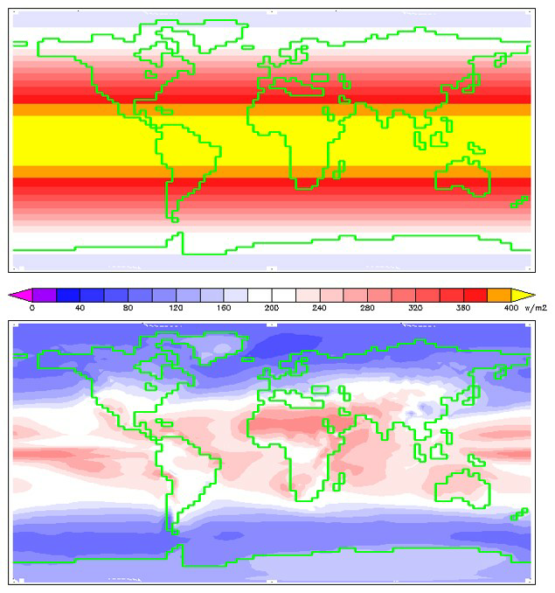

Figure 1: Maps of solar irradiance before and after passing through Earth’s atmosphere

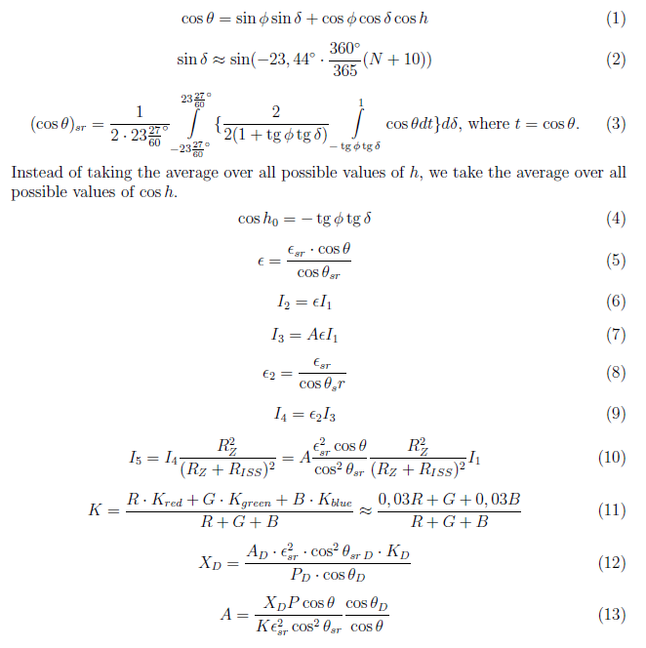

Figure 2: Mathematical equations mentioned in the physical model